

Bio-Informatics
( Course Code: BIO310 )

Name : Muhammad Abdullah
Roll No # FA24-BSE-042
Intructor Name : Afraz Ahmed

Open Quiz#4
Phylogenetic Algorithms

1. Phylogenetic Tree Construction Methods (with Examples)
UPGMA (Unweighted Pair Group Method with Arithmetic Mean)
This method generates a rooted tree by progressively grouping taxa based on genetic distance, assuming that evolution occurs at a constant rate (the molecular clock hypothesis). It's best suited for data where mutation rates are relatively uniform.
Example: Grouping closely related human populations by analyzing allele frequency similarities.
Neighbor-Joining (NJ)
NJ constructs an unrooted tree by iteratively connecting taxa that minimize the overall branch length. It doesn't assume equal evolutionary rates and is computationally efficient, making it ideal for broader phylogenetic comparisons.
Example: Mapping evolutionary relationships among humans, gorillas, and chimpanzees.
Maximum Parsimony (MP)
This method looks for the tree that explains the observed genetic data with the fewest evolutionary changes. It is effective for simple trees but may be unreliable when dealing with long branches or convergent evolution.
Example: Determining the evolutionary trajectory of a small group of mitochondrial DNA samples.
Maximum Likelihood (ML)
ML evaluates numerous possible trees and selects the one most likely to have produced the observed sequences under a chosen model of evolution. It's highly accurate but computationally demanding.
Example: Studying the evolution of human gene families using probabilistic models of nucleotide substitution.
Bayesian Inference
Bayesian approaches build upon ML by incorporating prior knowledge and generating a probability distribution across possible trees. This allows for estimating confidence in both tree structure and divergence times.
Example: Estimating the divergence time between Homo sapiens and Neanderthals using ancient DNA.

2. Most Suitable Method for Building a Human Family Tree
When reconstructing human pedigrees (family trees), the most appropriate method is a simplified version of Maximum Parsimony. Since the data involves recent and directly observable relationships, parsimony efficiently minimizes the number of relationship changes. It avoids complex assumptions about mutation rates and is intuitive for close, individual-level relationships.

3. A Sample Human Family Tree using MP4.

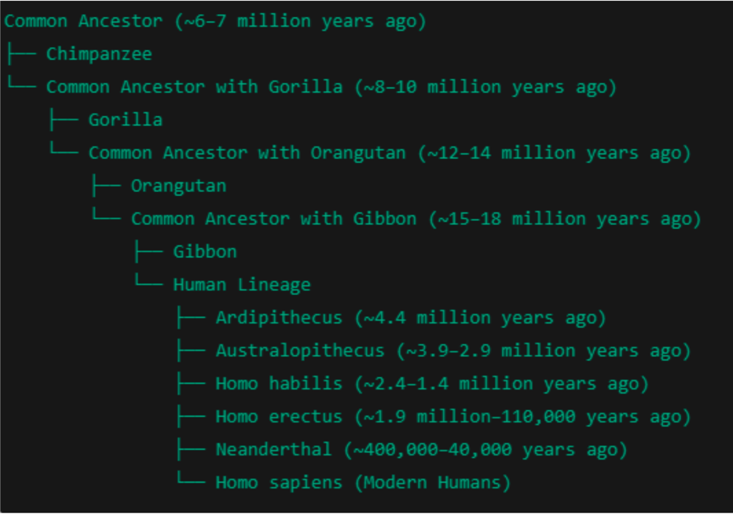

4. Why Phylogenetics Captures My Interest
Phylogenetics captivates me because it seamlessly integrates biology with computational logic and analytical thinking. It’s like decoding an ancestral puzzle, revealing evolutionary paths, migration patterns, and the emergence of new traits. It helps us understa
nd not only how species evolved but also how we're biologically connected across time and geography.
5. The Theory of Evolution Explained
The theory of evolution, originally proposed by Charles Darwin and refined through modern genetics, explains how life diversifies and adapts. Key points include:
- Genetic Variation: Individuals in a population differ genetically due to mutation and recombination.
- Inheritance: Traits are passed down from parents to offspring.
- Differential Reproduction: Organisms with traits better suited to their environment tend to survive and reproduce more successfully.
- Adaptation Over Time: These advantages accumulate across generations, resulting in evolutionary change.
- Speciation and Diversity: Over long periods, isolated populations can evolve into new species, creating the complex tree of life that phylogenetics seeks to map.

